SOFTWARE REQUIREMENTS SPECIFICATION

**For**

**PET ADOPTION SYSTEM**

**Prepared by:-**

*VALAVAN.K*

*VISHAL.K*

*SANJAY.E*

# Introduction

## Purpose

The main objective of this document is to illustrate the requirements of the project Library Management system. The document gives the detailed description of the both functional and non-functional requirements proposed by the client.The purpose of this project is to provide a friendly environment to maintain the details of books and library members.The main purpose of this project is to maintain easy circulation system using computers and to provide different reports. This project describes the hardware and software interface requirements using ER diagrams and UML diagrams.

## Document Conventions

* + - Entire document should be justified.
    - Convention for Main title

Font face: Times New Roman Font style: Bold

Font Size: 14

* + - Convention for Sub title

Font face: Times New Roman Font style: Bold

Font Size: 12

* + - Convention for body

Font face: Times New Roman Font Size: 12

## Scope of Development Project:

Animals at the shelter would be a good choice for first-time pet owners. This is because these animals will already be partially house trained and accustomed to people at the shelter. By choosing to adopt an animal from the shelter, you will be saving them from fear, distress, and death. Moreover, a lot of shelter animals are obedient pets that had their comfort and happiness snached away after being abandoned by their owners.

Adopting from a shelter would be a great choice for anyone, especially If you are a first-time pet parent or have little experience with animals. This is because shelters will guide you through the process and will also provide you with all the information you need, making it easier for you to take care of your adopted pet.

## Definitions, Acronyms and Abbreviations

JAVA -> platform independence SQL-> Structured query Language ER-> Entity Relationship

UML -> Unified Modeling Language

IDE-> Integrated Development Environment SRS-> Software Requirement Specification

## References

* + - Books

 **APA Style**: It provides examples of how to reference books in both print and ebook formats. The page also includes examples of how to reference whole authored books, whole edited books, republished books with editors, and several volumes of a multivolume work

**MLA and Chicago Style**: It provides detailed information on how to cite a book in each of these styles.

Websites

**https://github.com/topics/pet-adoption-website**

**https://www.vetstreet.com/our-pet-experts/our-guide-to-pet-adoption-websites**

# Overall Descriptions

## Product Function

Entity Relationship Diagram of Library Management System

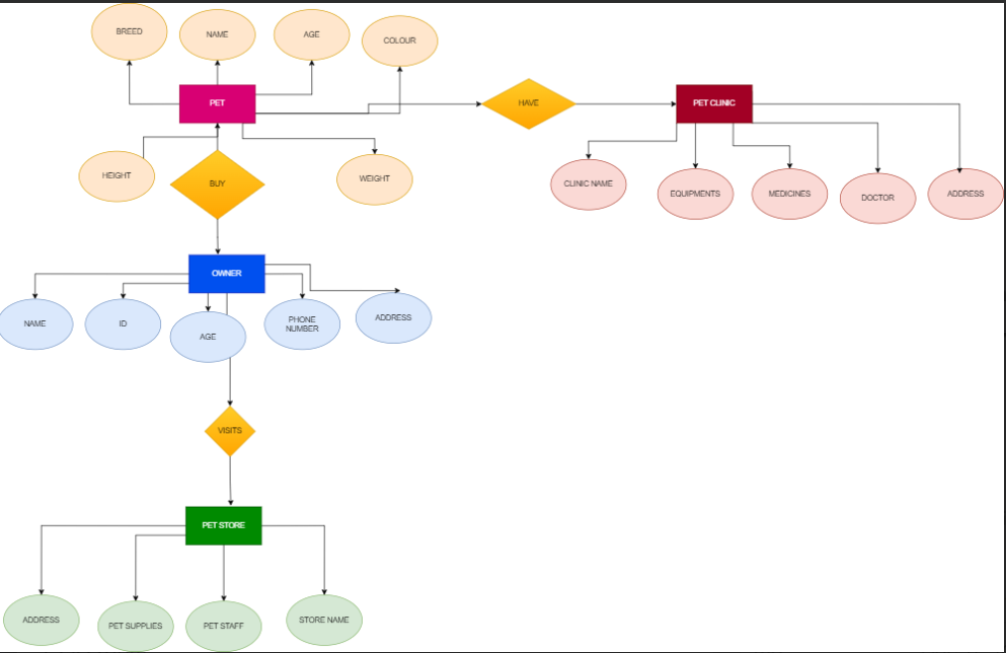 It discusses the current procedures for adapting or finding a pet and proposes an AI-based platform for animal lovers to provide a pet partner of their choosing by giving all of the required information. The paper also covers topics such as animal detection, classification, deep learning algorithms, adoption, and sentiment analysis. It provides examples of how to reference books in both print and ebook formats. The page also includes examples of how to reference whole authored books, whole edited books, republished books with editors, and several volumes of a multivolume work.

# USER CLASSES AND CHARACTERTICS:

They provide a list of characteristics that will help you be a successful adoptive parent. Some of these characteristics include being present, intentional, and resilient.

They provide a comprehensive guide on how to adopt a pet in India.

Here are some general requirements that you may need to fulfill when adopting a pet:

Some characteristics of adopting are:

* **Flexibility**: Adoptive parents need to be able to adapt to the changing needs and circumstances of their children, who may have experienced trauma, loss, or developmental delays
* **Humor**: Adoptive parents need to have a sense of humor to cope with the stress and difficulties of parenting, as well as to connect and bond with their children.
* **Patience**: Adoptive parents need to have patience for the long and complex adoption process, which may involve waiting, paperwork, legal issues, and agency involvement.
* **Advocacy**: Adoptive parents need to be advocates for their children, who may have special needs, educational challenges, or medical issues

## Operating Environment

It discusses the current procedures for adapting or finding a pet and proposes an AI-based platform for animal lovers to provide a pet partner of their choosing by giving all of the required information. The paper also covers topics such as animal detection, classification, deep learning algorithms, adoption, and sentiment analysis.

It provides examples of how to reference books in both print and ebook formats. The page also includes examples of how to reference whole authored books, whole edited books, republished books with editors, and several volumes of a multivolume work.

**2.3Assumptions and Dependencies**

The assumptions are:-

* + - The coding should be error free
    - The system should be user-friendly so that it is easy to use for the users
    - The information of all users is accessible by pet adoption website
    - The system should have more storage capacity and provide fast access to the database
    - The system should provide search facility and support quick transactions
    - The pet adoption system is running 24 hours a day
    - Users may access Internet browsing about pet adoption

The dependencies are:-

* + - The specific hardware and software due to which the product will be run
    - On the basis of listing requirements and specification the project will be developed and run
    - The end users (admin) should have proper understanding of the product
    - The system should have the general report stored
    - The information of all the users must be stored in a database that is accessible by the Library System
    - Any update regarding the book from the library is to be recorded to the database and the data entered should be correct

## Requirement

Software Configuration:-

This software package is developed using java as front end which is supported by sun micro system. Microsoft SQL Server as the back end to store the database.

Operating System: Windows NT, windows 98, Windows XP Language: Java Runtime Environment, Net beans 7.0.1 (front end) Database: MS SQL Server (back end)

Hardware Configuration:- Processor: Pentium(R)Dual-core CPU Hard Disk: 40GB

RAM: 256 MB or more

## Data Requirement

The inputs consist of the query to the database and the output consists of the solutions for the query. The output also includes the user receiving the details of their accounts. In this project the inputs will be the queries as fired by the users like create an account, selecting books and putting into account. Now the output will be visible when the user requests the server to get details of their account in the form of time, date and which books are currently in the account.

# External Interface Requirement

## GUI

If you are looking to adopt a pet animal, there are several steps you can follow to make the process easier. Here is a step-by-step guide to adopting a dog in India:

1. **Decide what kind of dog you want**: Consider your lifestyle, budget, home space, and family before deciding which kind of dog you want to bring home. While families with kids or young couples might opt for a lively dog, seniors can go for aged canines who require less training and can be ideal retirement companions. A large dog is not suitable for people residing in less spacious apartments. At the same time, they also have to ensure zero inconvenience to the neighbors. Every dog is different – some are high-maintenance while others can make do with a little love, care, and attention. Research thoroughly.
2. **Find out the nearby shelters**: Locate the nearby dog shelter and visit the place several times keeping in mind who you want in your home. Interact with the dogs at the shelter
3. **Bond with the dogs at the shelter**: Interact with the dogs at the shelter
4. **Follow the required and necessary procedures**: Follow the required and necessary procedures.

# System Features

The users of the system should be provided the surety that their account is secure. This is possible by providing:-

* User authentication and validation of members using their unique member ID
* Proper monitoring by the administrator which includes updating account status, showing a popup if the member attempts to issue number of books that exceed the limit provided by the library policy, assigning fine to members who skip the date of return
* Proper accountability which includes not allowing a member to see other member’s account. Only administrator will see and manage all member accounts

# Other Non-functional Requirements

## Performance Requirement

The proposed system that we are going to develop will be used as the Chief performance system within the different campuses of the university which interacts with the university staff and students. Therefore, it is expected that the database would perform functionally all the requirements that are specified by the university.

* + - The performance of the system should be fast and accurate
    - Pet adoption System shall handle expected and non-expected errors in ways that prevent loss in information and long downtime period. Thus it should have inbuilt error testing to identify invalid username/password
    - The system should be able to handle large amount of data. Thus it should accommodate high number of books and users without any fault

## Safety Requirement

The database may get crashed at any certain time due to virus or operating system failure. Therefore, it is required to take the database backup so that the database is not lost. Proper UPS/inverter facility should be there in case of power supply failure.

## Security Requirement

* + - System will use secured database
    - Normal users can just read information but they cannot edit or modify anything except their personal and some other information.
    - System will have different types of users and every user has access constraints
    - Proper user authentication should be provided
    - No one should be able to hack users’ password
    - There should be separate accounts for admin and members such that no member can access the database and only admin has the rights to update the database.

## Requirement attributes

* + - There may be multiple admins creating the project, all of them will have the right to create changes to the system. But the members or other users cannot do changes
    - The project should be open source
    - The Quality of the database is maintained in such a way so that it can be very user friendly to all the users of the database
    - The user be able to easily download and install the system

## Business Rules

A business rule is anything that captures and implements business policies and practices. A rule can enforce business policy, make a decision, or infer new data from existing data.This includes the rules and regulations that the System users should abide by. This includes the cost of the project and the discount offers provided. The users should avoid illegal rules and protocols. Neither admin nor member should cross the rules and regulations.

## User Requirement

The users of the system are members and Librarian of the university who act as administrator to maintain the system. The members are assumed to have basic knowledge of the computers and internet browsing. The administrators of the system should have more knowledge of the internals of the system and is able to rectify the small problems that may arise due to disk crashes, power failures and other catastrophes to maintain the system. The proper user interface, user manual, online help and the guide to install and maintain the system must be sufficient to educate the users on how to use the system without any problems.

The admin provides certain facilities to the users in the form of:-

* + - Backup and Recovery
    - Forgot Password
    - Data migration i.e. whenever user registers for the first time then the data is stored in the server
    - Data replication i.e. if the data is lost in one branch, it is still stored with the server
    - Auto Recovery i.e. frequently auto saving the information
    - Maintaining files i.e. File Organization
    - The server must be maintained regularly and it has to be updated from time to time

# Other Requirements

## Data and Category Requirement

There are different categories of users namely teaching staff, Librarian, Admin, students etc. Depending upon the category of user the access rights are decided.It means if the user is an administrator then he can be able to modify the data,delete, append etc. All other users except the Librarian only have the rights to retrieve the information about database. Similarly there will be different categories of books available. According to the categories of books their relevant data should be displayed. The categories and the data related to each category should be coded in the particular format.

## Appendix

A: Admin, Abbreviation, Acronym, Assumptions; B: Books, Business rules; C: Class, Client, Conventions; D: Data requirement, Dependencies; G: GUI; K: Key; L: Library, Librarian; M: Member; N: Non-functional Requirement; O: Operating environment; P: Performance,Perspective,Purpose; R: Requirement, Requirement attributes; S: Safety, Scope, Security, System features; U: User, User class and characteristics, User requirement;

## Glossary

The following are the list of conventions and acronyms used in this document and the project as well:

* + - Administrator: A login id representing a user with user administration privileges to the software
    - User: A general login id assigned to most users
    - Client: Intended users for the software
    - SQL: Structured Query Language; used to retrieve information from a database
    - SQL Server: A server used to store data in an organized format
    - Layer: Represents a section of the project
    - User Interface Layer: The section of the assignment referring to what the user interacts with directly
    - Application Logic Layer: The section of the assignment referring to the Web Server. This is where all computations are completed
    - Data Storage Layer: The section of the assignment referring to where all data is recorded
    - Use Case: A broad level diagram of the project showing a basic overview
    - Class diagram: It is a type of static structure diagram that describes the structure of a system by showing the system’s cases, their attributes, and the relationships between the classes
    - Interface: Something used to communicate across different mediums
    - Unique Key: Used to differentiate entries in a database

## Class Diagram

A class is an abstract, user-defined description of a type of data. It identifies the attributes of the data and the operations that can be performed on instances (i.e. objects) of the data. A class of data has a name, a set of attributes that describes its characteristics, and a set of operations that can be performed on the objects of that class. The classes’ structure and their relationships to each other frozen in time represent the static model. In this project there are certain main classes

which are related to other classes required for their working. There are different kinds of relationships between the classes as shown in the diagram like normal association, aggregation, and generalization. The relationships are depicted using a role name and multiplicities. Here ‘Librarian’, ‘Member’ and ‘Books’ are the most important classes which are related to other classes.

